1.0 Introduction

1.1 Purpose

This game was designed to teach a wide array of age ranges skills for problem solving. This software was designed so students can grow mentally with the software and are able to choose ascending difficulties as they progress in age and grade. The difficulty and interaction with the Woods game will change and mature as the student does with dynamic difficulty settings that are able to be chosen at the beginning of the game.

1,2 Wandering the Woods Game

The Wandering the woods game is an interactive experience designed for two or more players to work cooperatively. By alternating turns at the same machine with mouse clicks to move their unique players Students can work together to reach a wide array of game play modes as their ages progress.

2.0 Process Model

Since analyses and testing are straightforward Wandering The Woods the uses a waterfall process model

Communication --> Planning --> Modeling --> Construction --> Deployment

This allows for easy understanding and planning. The size of Wandering the Woods allows for compact organization and allows for optimum planning.

3.0 Use Cases.

3.1 K2

Primary Actor(s): K-2 students

Preconditions: The game has been started and students assigned players

Description: Students will experience chance encounters and see physical representations until they manage to meet in the same position.

Acceptance criteria: Students have persevered and reached the end of their wandering finding themselves at the same position.

3.2 3-5

Primary Actor(s): 3-5 students

Preconditions: The game has been started and students assigned players

Description: Students will begin to understand the development side as they are given the option to modify parameters of the game.

Acceptance criteria: Students have learned manipulation of game parameters and how it effects game play and win conditions.

3.3 6-8

Primary Actor(s): 6-8 students

Preconditions: The game has been started and students assigned players

Description: Students will fully cross into the development side and been given more parameters. Furthermore students will understand the purpose of this level is to experiment with parameters and outcomes not simply just meet in the woods.

Acceptance criteria: Students have run experiments with game parameters and understand how their modifications have worked

4.0 UML Model

4.1 Use Case relationship

The Actors in the model are the students who try any of the three use cases. The first level is only two, and the next two levels contain the possibility for more. The users will make choices at first to achieve the win condition of the game and meet. Further levels the user will manipulate game parameters and the goal becomes not just to meet in the woods learn how manipulation effects game play.

4.2 Deployment

Wandering the woods game runs on simple system requirements that shoould be well within the range of public school computers. Users only need a keyboard and mouse to input data and play the game.

4.3 Class Diagram

Main.py file:

Level Selection

Device:

Mouse Control – for gameplay and moving in the woods.

Keyboard – For user input and game parameter selection

K-2

Player - user specified player

Move – wandering decision

2-5

Player – user specified player

Parameter Grid = user specified grid size

Move – wandering decision

6-8

Player – user specified player

Parameter Grid – user specified grid size

Move – wondering decision

Parameter Prortocal – Overall move type and trend.

4.4 State Diagram

The system start state begins depending on chosen level. For K-2 Students will start on opposite diagonal corners of the square grid. For 3-5 and 6-8 students can start at various positions of square or possible rectangle grid. The grid will reset with subsequent plays.

4,5 Activity Diagram

High level activity of users will change based on chosen level. For K-2 Wandering movements are random students will take turns randomly wandering the woods until a simple win condition is met. Movement in subsequent levels will change based on weather students find each other for 3-5 two students who found each other in the woods will move cooperatively until all players are found. The final level will introduce different protocols for players to wander.

5.0 Customer Journey Map

The overall journey of Users progressing through levels will be to shift from reacting to random movements to taking control of the game itself. As parameters become more open Users will get the chance to experience dynamic game play as they are able to change the game.

6.0 Personas

Player personas between students are all equal. Users will work cooperatively to meet goals and conditions. The personas at the start of the simulation are the same at the end it is their positions that matter. Customer profiles include schools and learning institutions with a wide array of age ranges.

7. UI Mock Up

The game interface is a simple grid consisting of clearly defined areas and user characters. Representations of character models will change position throughout the game.

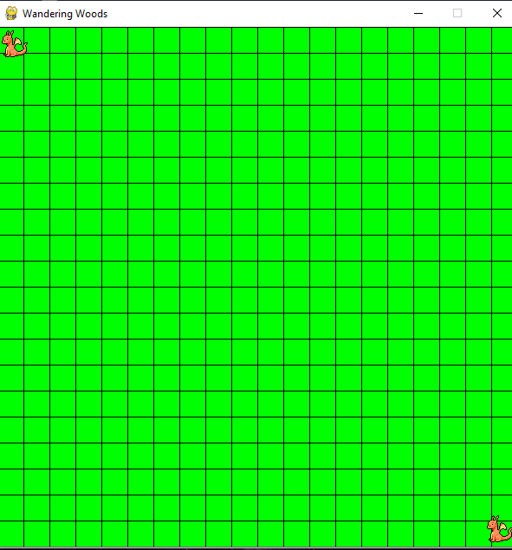

8.0 Testing Stratagey

It is of great importance that this software consists of a testing pahse including users from possible age groups in the appropriate levels. The development team has carried out testing for usability and validation.

8.1 Usability

The development team is looking to evaluate ease of understanding and intuitiveness of controls and win parameters among user of age ranges k-8.

8.2 Validation

After test cases have been tested and reviewed validation testing can start with testing to gauge user retention and teacher involvement. This will then be validated by project stakeholders.